Project 1: High-Gain Wi-Fi Antenna Design(Capstone)
The project involved creating a specialized antenna to boost Wi-Fi signal strength and range. It focused on analyzing RF propagation to reduce interference and optimize performance through simulation before prototyping.
Tools Used: Simulation tools (CST/HFSS), RF Analyzers, Prototyping kits.
Learning Outcome: Mastered RF optimization techniques to minimize signal loss and maximize coverage.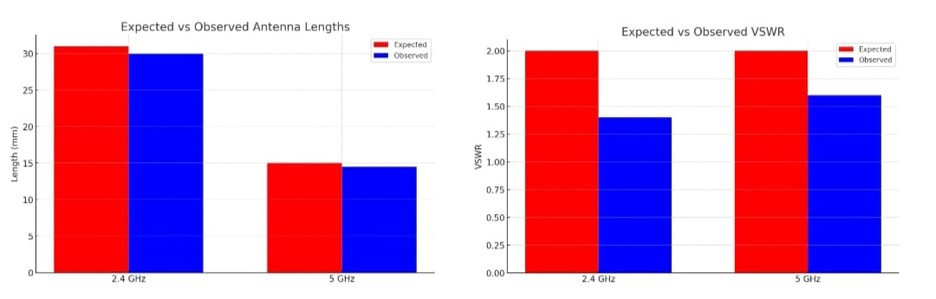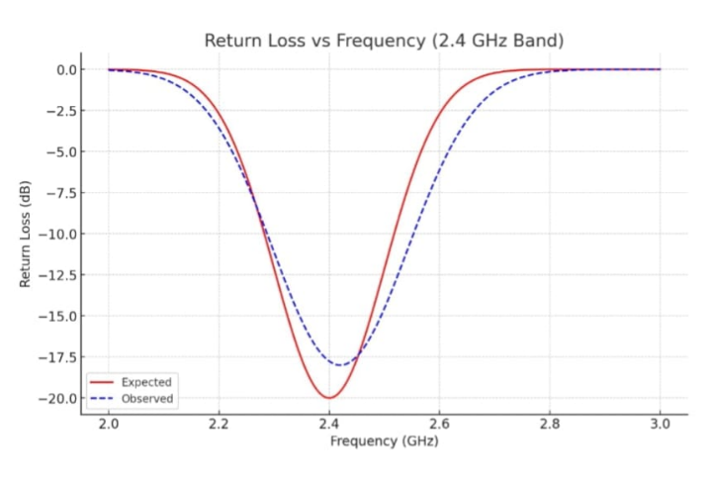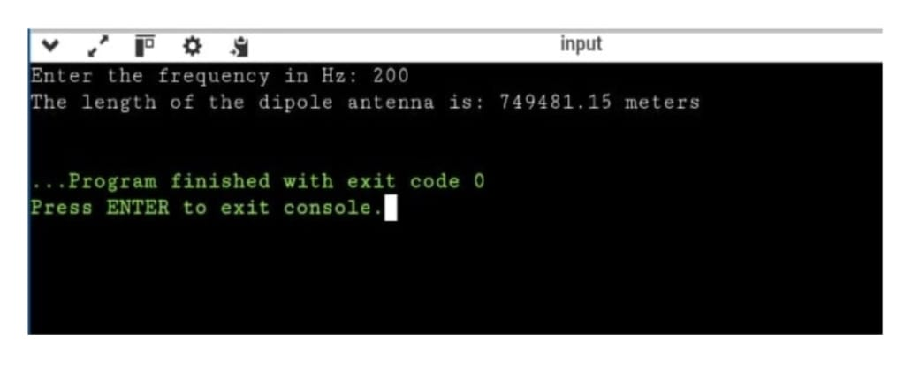

Project 2: Seed Sowing Rover
This rover automates the agricultural process of planting seeds using either autonomous or remote control. It features a custom mechanical wheel and drilling system integrated with microcontrollers for precise movement.
Tools Used: Arduino/ESP8266, DC Motors, Sensors, Mechanical drilling components.
Learning Outcome: Developed practical skills in hardware integration and mechanical automation for agricultural solutions.
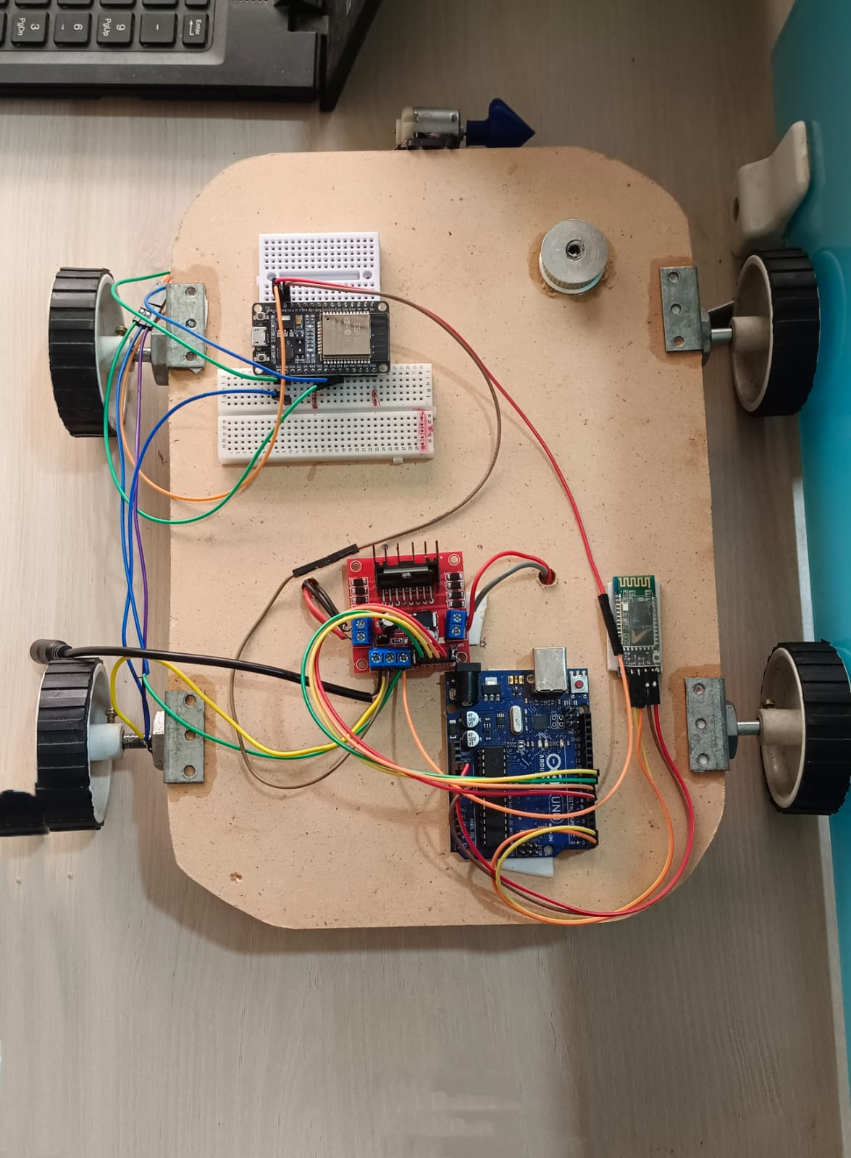

Project 3: Parking System Allotment
Designed a digital interface to manage and allocate parking spaces efficiently. The focus was on creating a user-friendly flow that helps drivers locate and reserve spots in real-time.
Tools Used: Figma.
Learning Outcome: Acquired proficiency in UI/UX design principles and interactive prototyping for management systems.
